Procedural Cohesion

📌 Definition:
# Source: AI Source: Provided by: [Data Path: Persons Table -> ID Column: 1, Name_En Column: Motasem Essam] -> From: [Chatgpt (GPT‑5 Mini)] on [12/9/2025]
Procedural Cohesion occurs when elements of a class/module are grouped because they follow a specific sequence of steps, but they may not operate on the same data.

🧠 Simple idea:
# Source: AI Source: Provided by: [Data Path: Persons Table -> ID Column: 1, Name_En Column: Motasem Essam] -> From: [Chatgpt (GPT‑5 Mini)] on [12/9/2025]
“Grouped by steps, not by purpose” 🪜

🔍 Key characteristics:
# Source: AI Source: Provided by: [Data Path: Persons Table -> ID Column: 1, Name_En Column: Motasem Essam] -> From: [Chatgpt (GPT‑5 Mini)] on [12/9/2025]
- 🪜 Methods follow a specific execution order
- ⚠️ Steps may be logically related by procedure, not by data or function
- 🟡 Moderate cohesion (weaker than communicational)
- ❌ Less flexible and reusable

📊 Example:
# Source: AI Source: Provided by: [Data Path: Persons Table -> ID Column: 1, Name_En Column: Motasem Essam] -> From: [Chatgpt (GPT‑5 Mini)] on [12/9/2025]
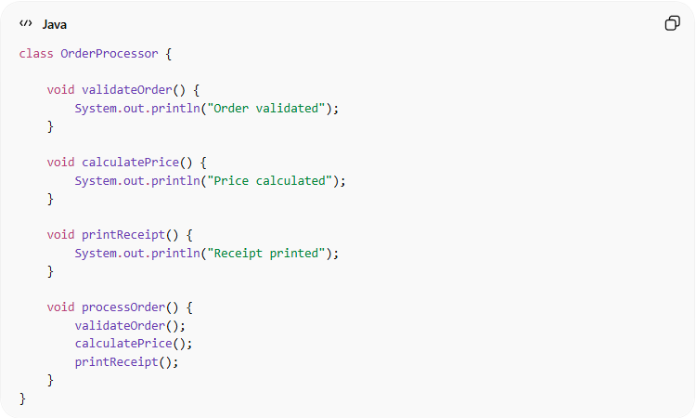
class OrderProcessor {

void validateOrder() {
System.out.println("Order validated");
}

void calculatePrice() {
System.out.println("Price calculated");
}

void printReceipt() {
System.out.println("Receipt printed");
}

void processOrder() {
validateOrder();
calculatePrice();
printReceipt();
}
}
- ✅ Methods are grouped because they follow a procedure (steps)
- ❌ Not all methods share the same data or single purpose

🛡️ Avoiding Procedural Cohesion Example:
# Source: AI Source: Provided by: [Data Path: Persons Table -> ID Column: 1, Name_En Column: Motasem Essam] -> From: [Chatgpt (GPT‑5 Mini)] on [12/9/2025]
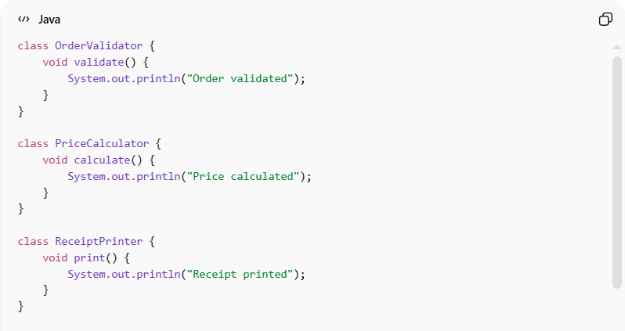
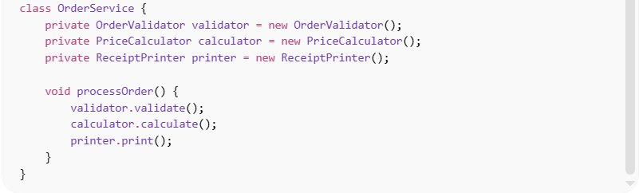
class OrderValidator {
void validate() {
System.out.println("Order validated");
}
}

class PriceCalculator {
void calculate() {
System.out.println("Price calculated");
}
}

class ReceiptPrinter {
void print() {
System.out.println("Receipt printed");
}
}

class OrderService {
private OrderValidator validator = new OrderValidator();
private PriceCalculator calculator = new PriceCalculator();
private ReceiptPrinter printer = new ReceiptPrinter();

void processOrder() {
validator.validate();
calculator.calculate();
printer.print();
}
}
Usage:
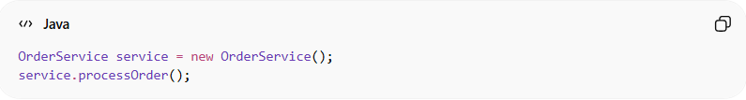
OrderService service = new OrderService();
service.processOrder();
✅ Key improvements:
- 🧩 Each class has a single responsibility
- 🔄 Steps are independent and reusable
- ⚙️ Easier to modify or extend each step
- 🔗 Reduced procedural dependency inside one class

⚙️ Best Practice:
# Source: AI Source: Provided by: [Data Path: Persons Table -> ID Column: 1, Name_En Column: Motasem Essam] -> From: [Chatgpt (GPT‑5 Mini)] on [12/9/2025]
- Break procedures into smaller, focused classes or methods
- Prefer functional or communicational cohesion when possible
- Keep steps clear and modular
- Use procedural cohesion only when step order is the main concern

